Getting Started with the Fault Trees from Physics Feature

**I. View some sample models**

1) From the Sirius Perspective, create a new modeling project:

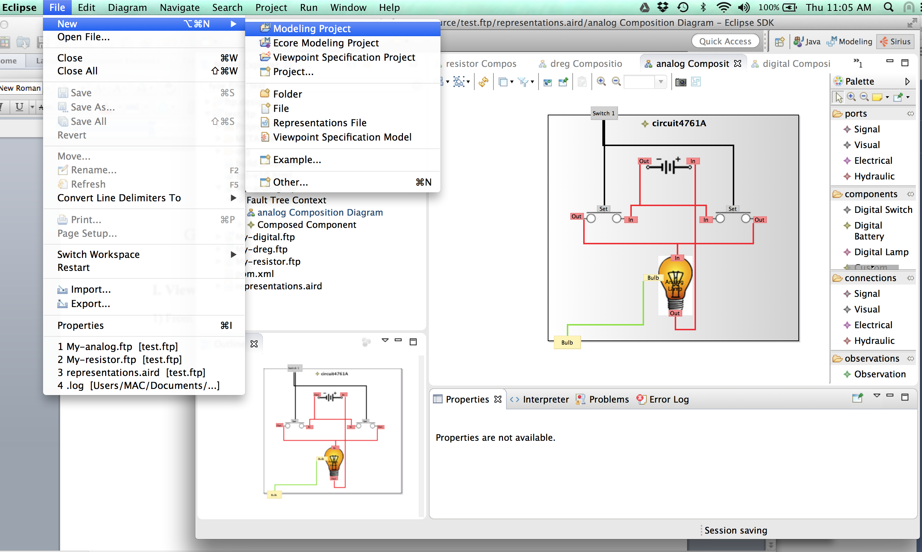

2) Enter a name for your project (sample, in this case) then click Finish: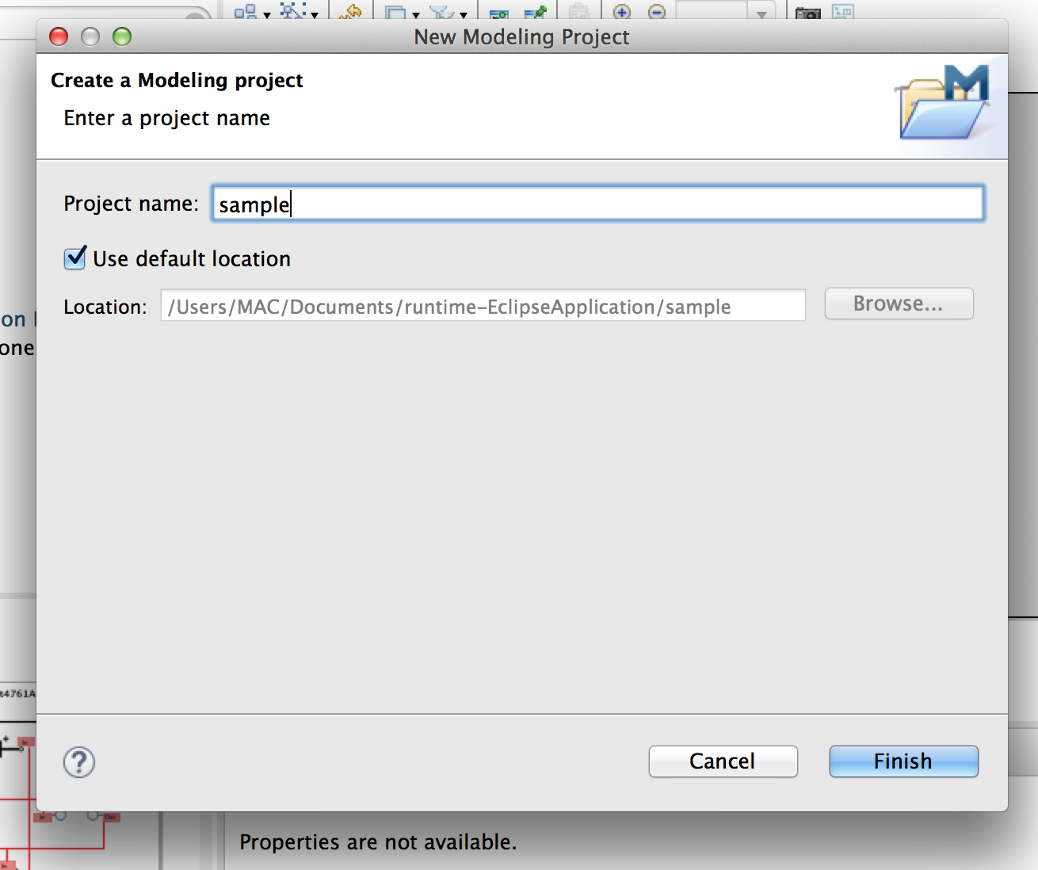

3) Import into your workspace project a sample FTP model file from disk, or use the CertWare Safety Case Examples Wizard to install one of the example FTP models into your project folder. In this case we use the Wizard to select a D-type register model from the examples as shown.

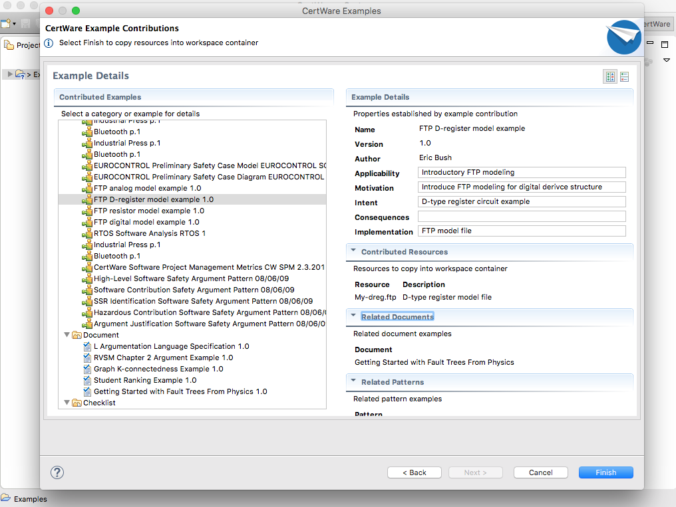

4) Right-click on your new project’s root folder and select Viewpoints Selection:

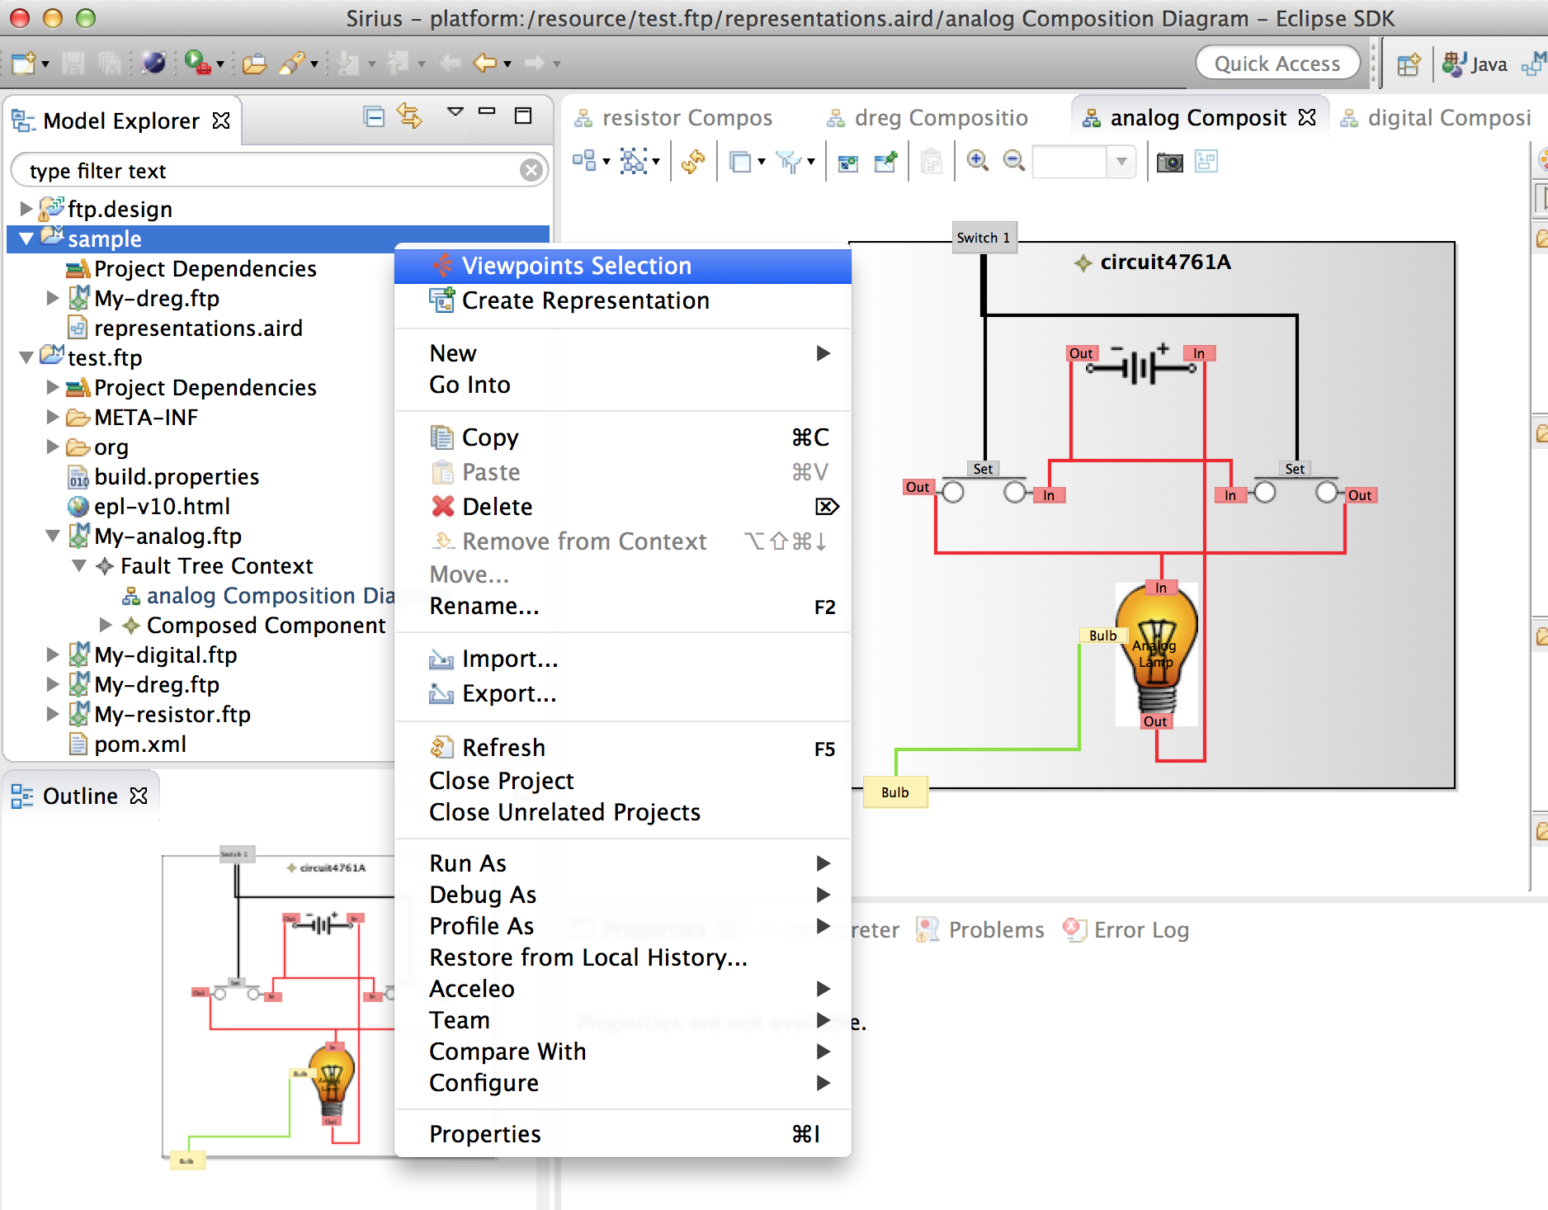

5) Choose the Fault Trees from Physics viewpoint and hit OK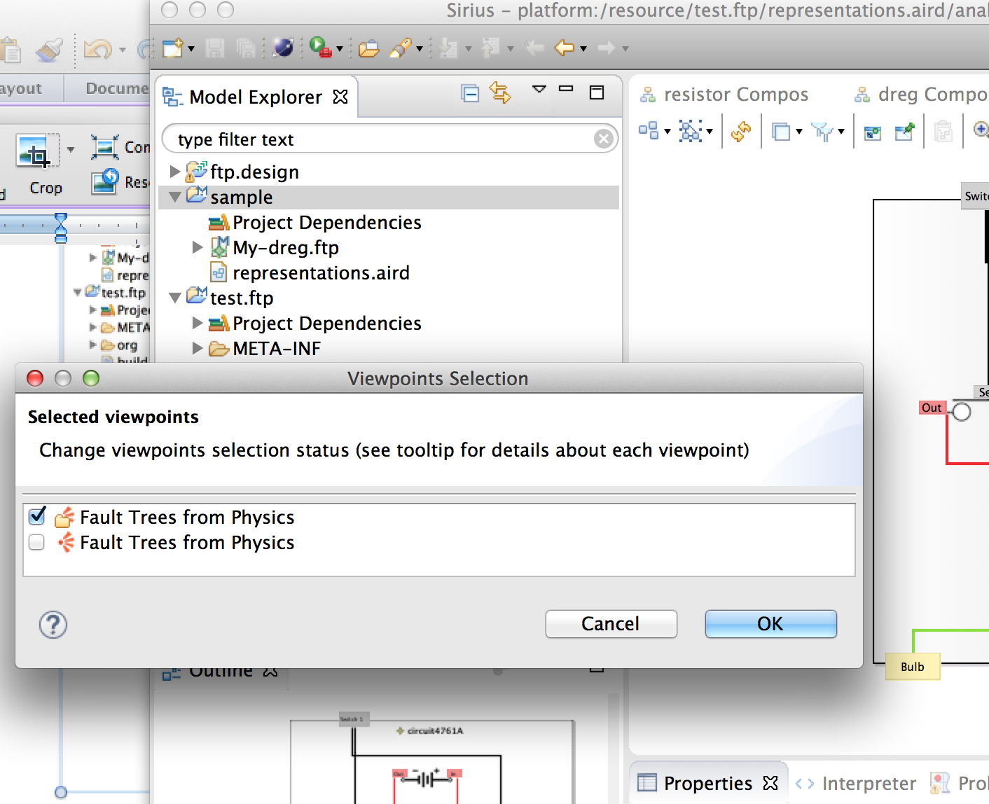

6) Expand your imported FTP model (My-dreg.ftp) , right-click on the Fault Tree Context element, select New Representation, then new Composition Diagram:

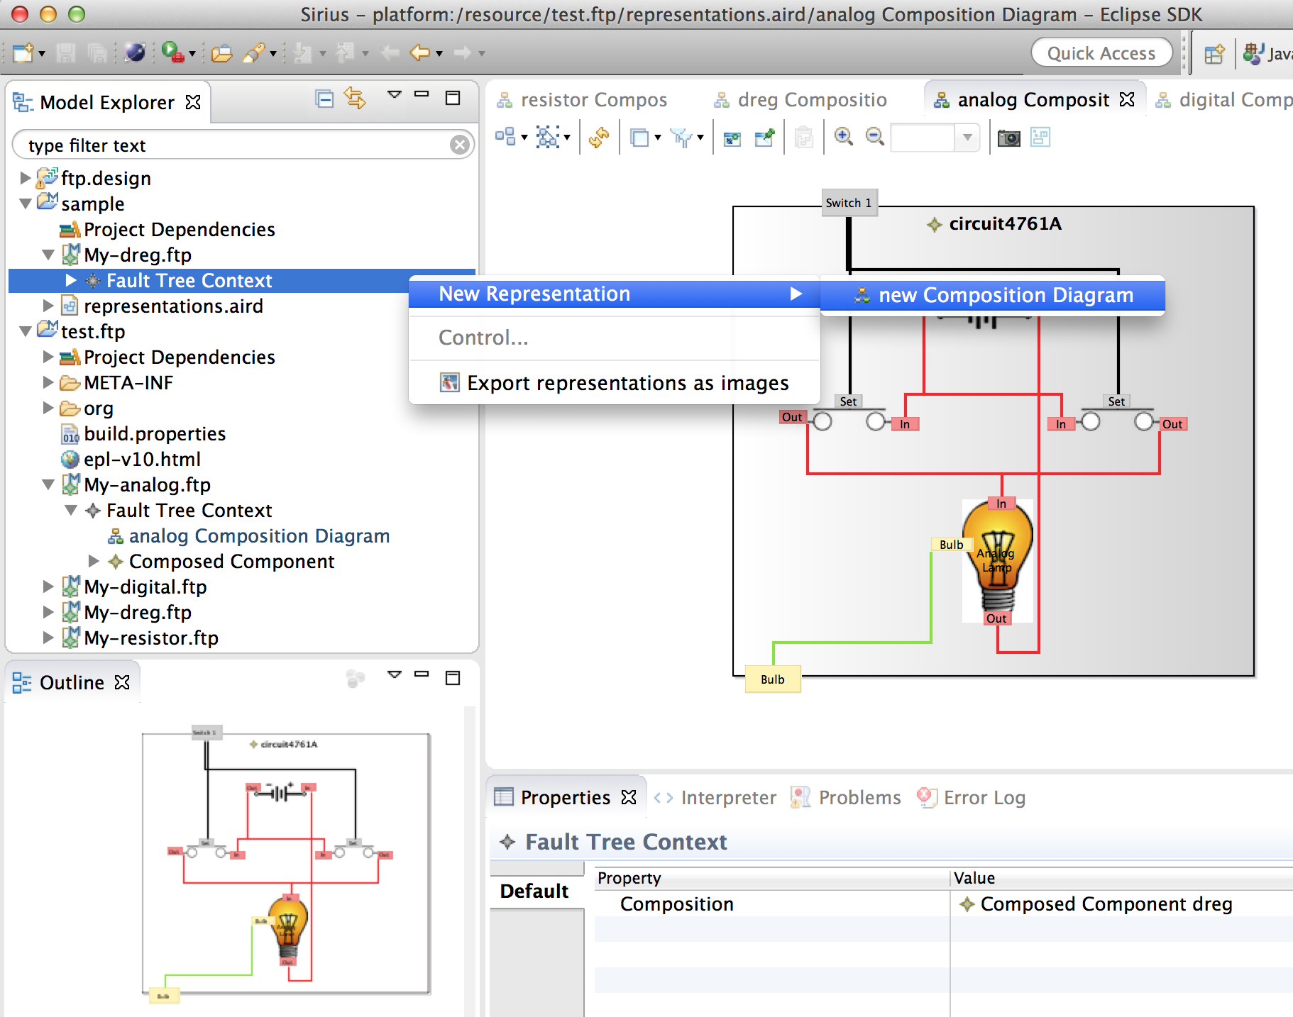

7) Give the diagram a name (in the dialog), hit OK, and a new Composition Diagram for My-dreg.ftp will appear.

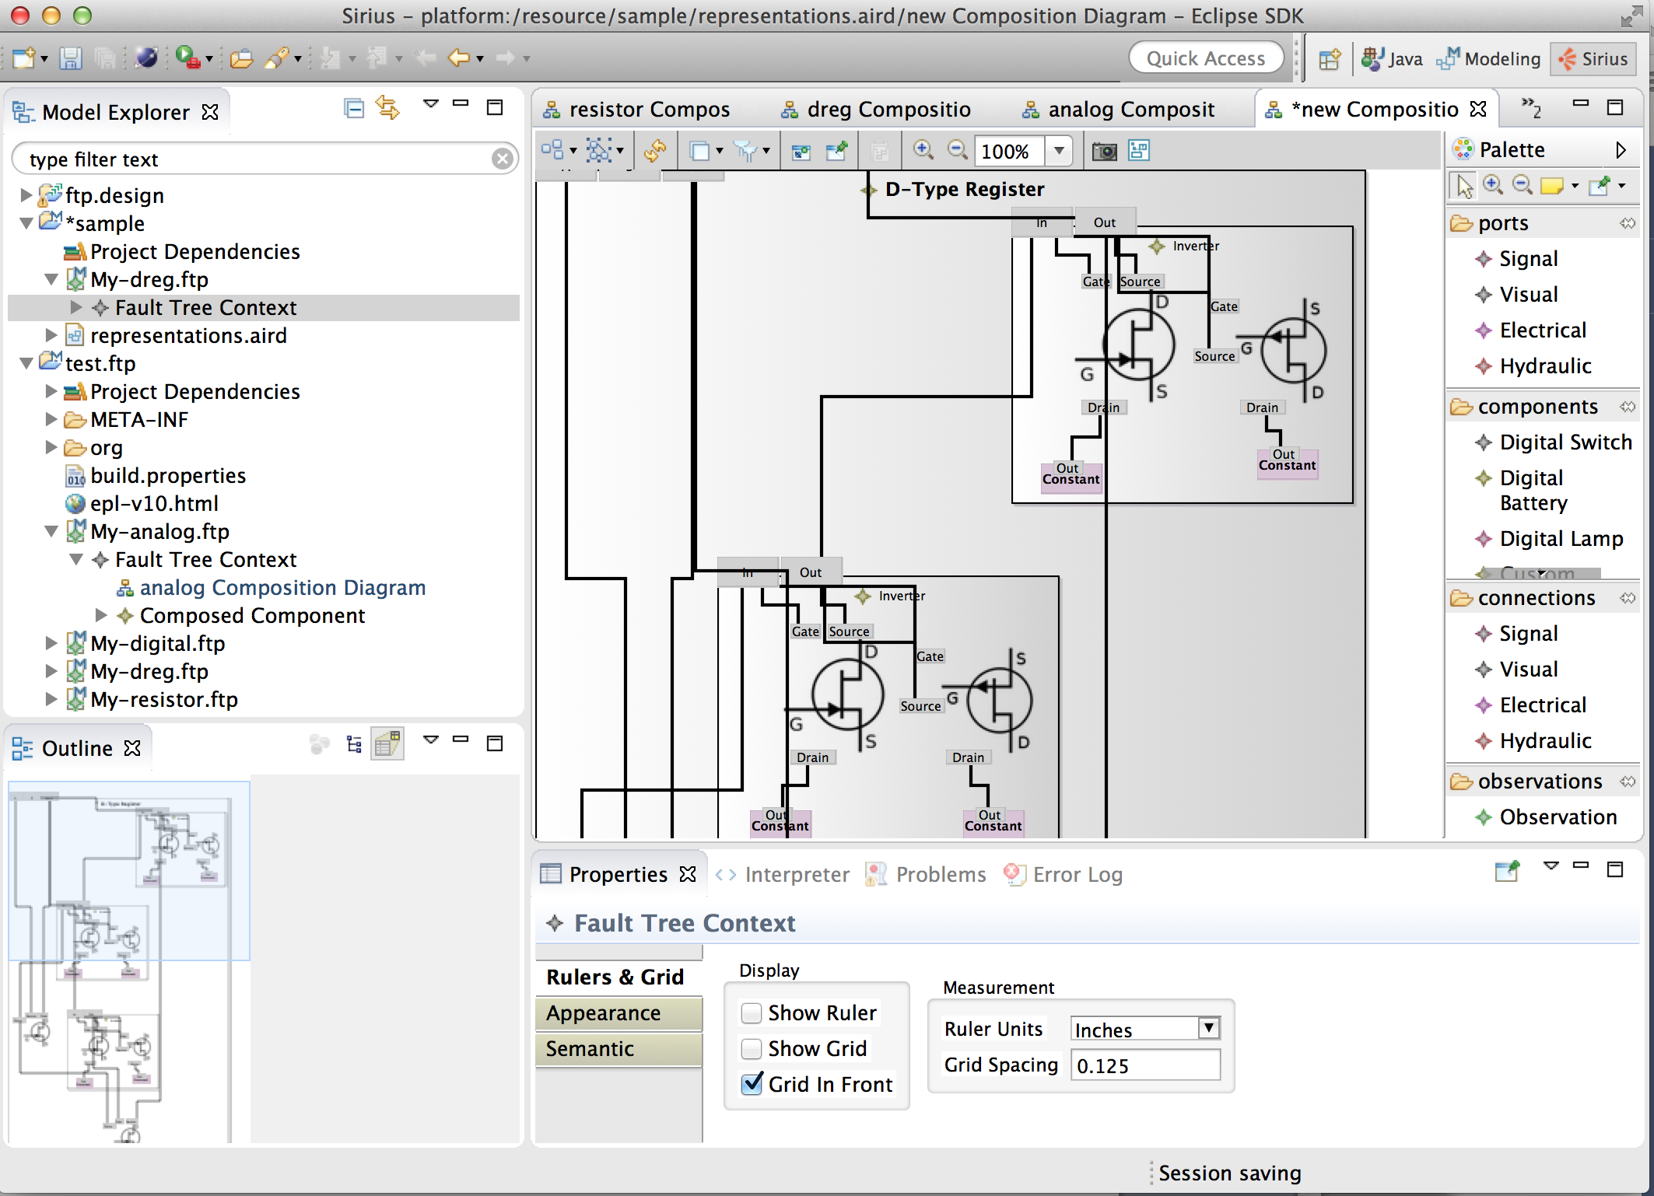

Sirius chooses its own, default layout, which is often not optimal. You may select and drag various elements, including components, connections, and ports, to achieve a more pleasing layout. When you save the diagram, Sirius will remember your custom layout.

8) Repeat steps 3 through 7 to explore the other sample ftp models.

9) Create a fault tree diagram from My-resistor.ftp. By clicking on the Observation element in the palette on the right, you can place an Observation anywhere outside of your top-level composition. The Observation object will be automatically populated with default values for each of the top-level composition’s ports. These can be changed in the property editor window at the bottom of the screen. You would typically set these values to some aberrant observation that will form the root of a fault tree. The My-resistor model comes pre-populated with 3 Observations representing the same aberrant scenario, but different limits on the number of fault states permitted in the tree. Right-click on any of the Observation objects to get a create a new Fault Tree diagram for the Observation.

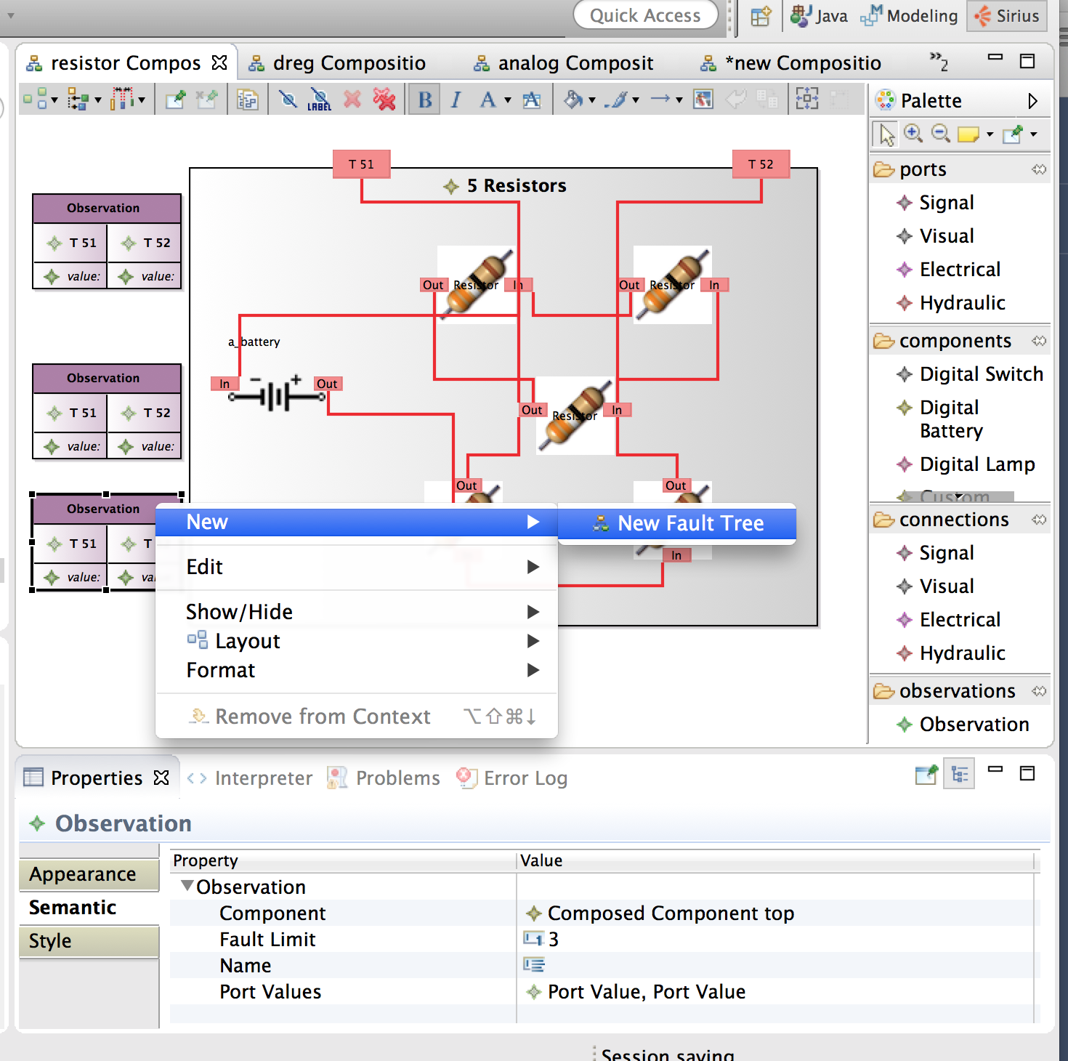

**I. Create your own system model and fault trees from scratch:**

1) Right-click on you new project’s root and select New -> Other …

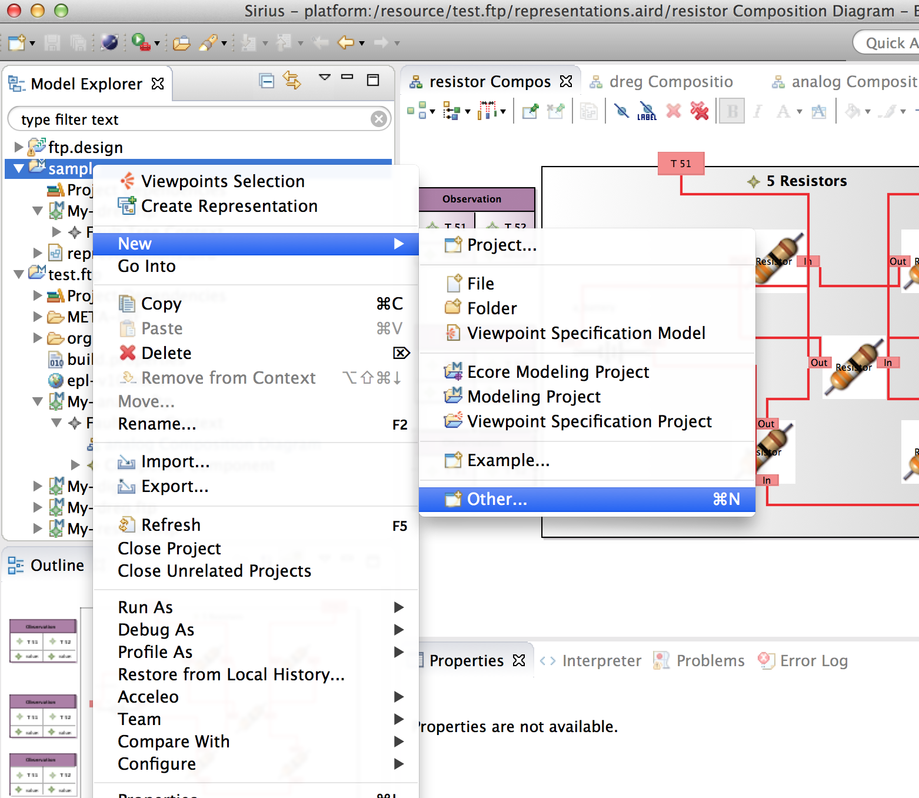

2) Select Example EMF Model Creation Wizards -> Ftp Model

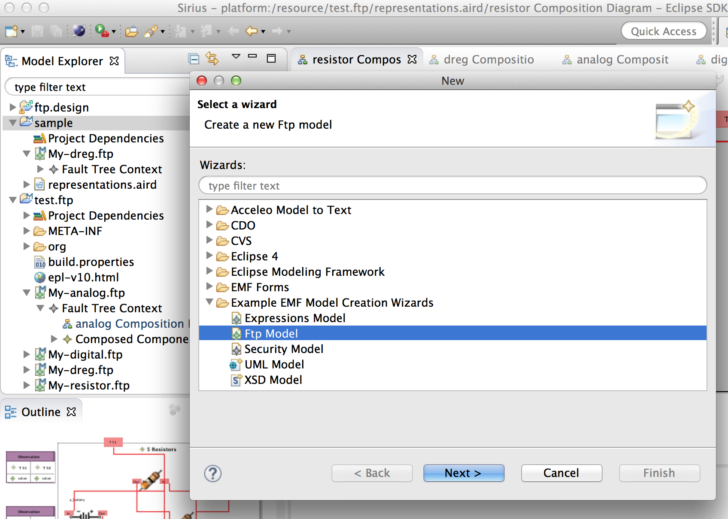

3) Give you new model a name, then select Fault Tree Context from the drop-down list of model objects. Although you could create an EMF model for any of the objects listed, only the top one, Fault Tree Context, is known to the Sirius diagram editor workbench.

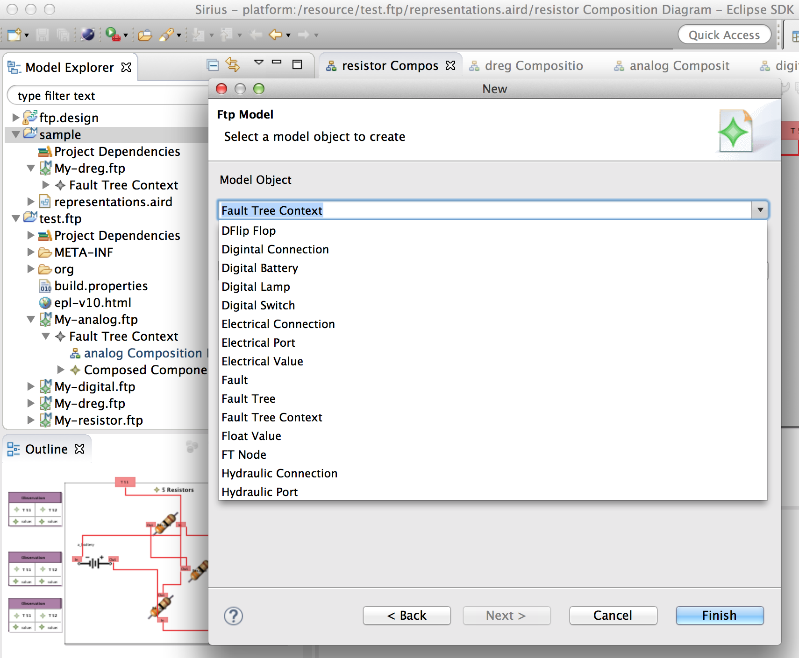

4) Sirius will open the standard EMF model tree and property editor, from which you could create your model elements, but the whole point of this CertWare feature is to create your system of components graphically with the workbench. To do this, expand your new model (My-ftp in the example below) in the Model Explorer window on the upper left, then right-click on Fault Tree Context -> New Representation -> New Composition Diagram.

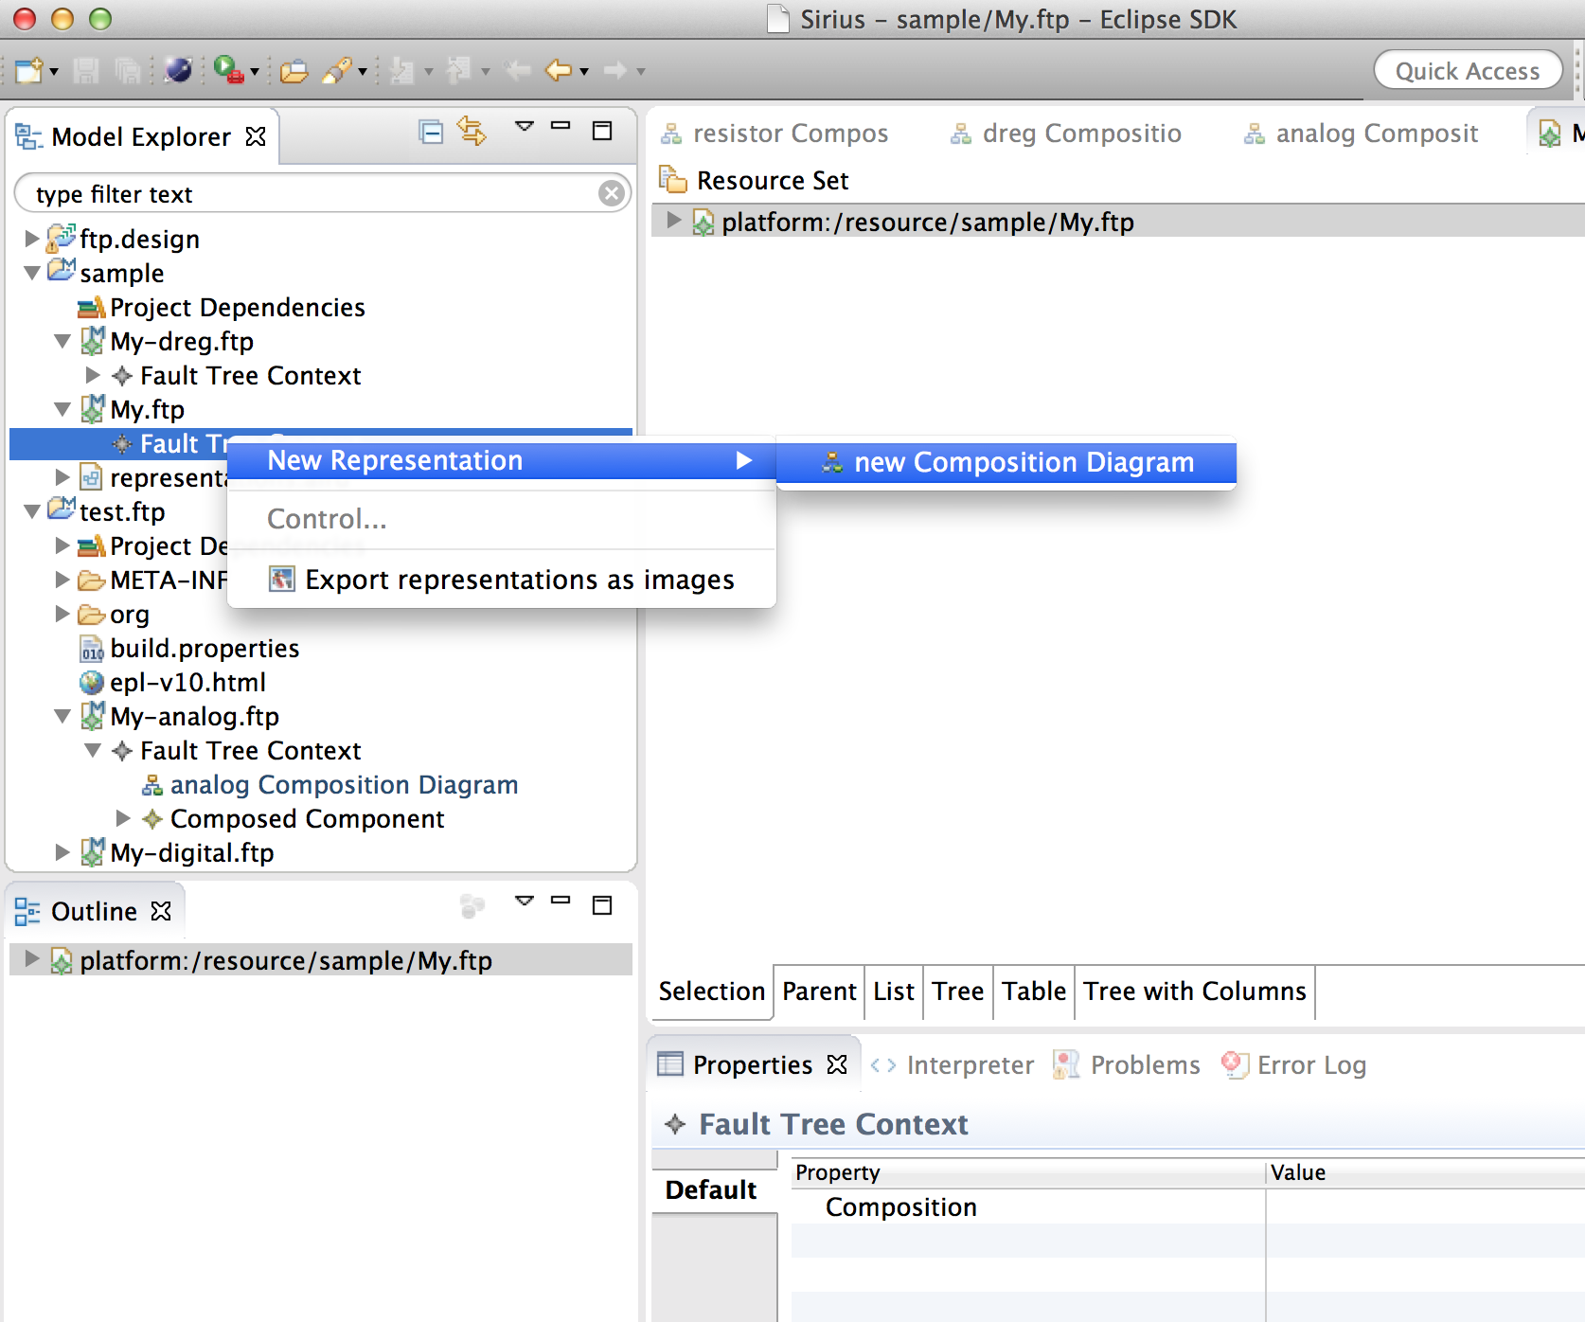

This will create an empty diagram, with an element palette on the right, in which you can compose your new system.

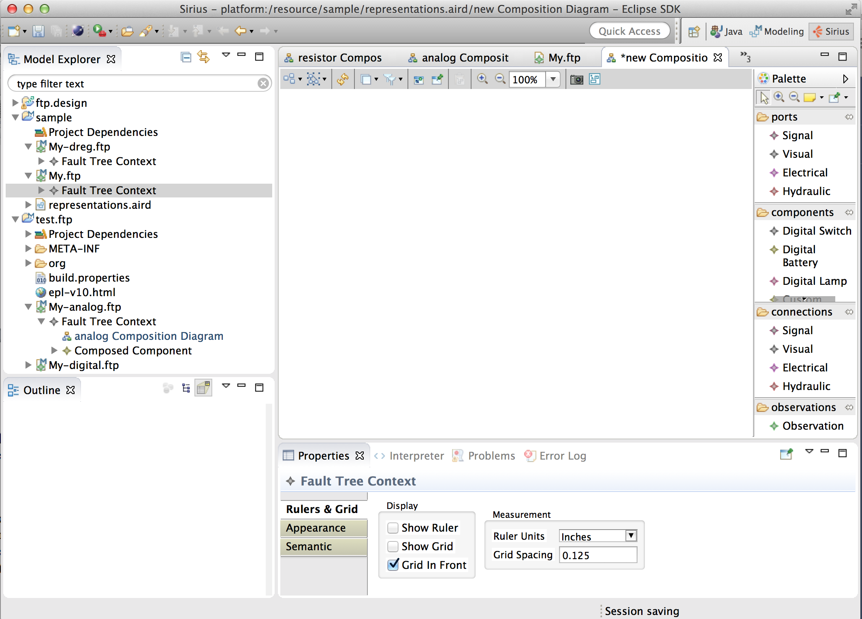

The various component, connection, and port elements that you can choose from have corresponding signal, electrical, hydraulic, and visual types. These types are all known semantically to the workbench, so the graphical editor will prevent your from composing compositions with incompatible types. Sirius will keep your diagram view and your EMF model view in sync each time you save a change to either.